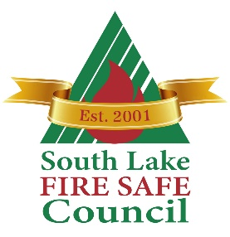

**South Lake Fire Safe Council**

**Right of Entry (Temporary)**

Permission is hereby granted to the South Lake Fire Safe Council, its officers, employees, designees to enter upon our land for the purpose of chipping brush and debris and all incidents there to, pursuant to the requirements of the South Lake Fire Safe Council’s fuel reduction program.

This is not a request for permanent easement and/or right-of-way, and this permission automatically terminates upon completion of the work.

INDEMNIFICATION-HOLD HARMLESS AGREEMENT

1. COUNCIL is to indemnify OWNER against loss or damage caused by any wrongful or negligent act of South Lake Fire Safe Council, its agents or employees ln the course of their employment as may be provided for in the California Entity Tort Claims Act.
2. COUNCIL further indemnifies and holds harmless OWNER from any and all claims, lawsuits, losses and damages, brought for, or on account of, injuries or death of any person or persons arising out of, or alleged to arise out of, or resulting from its agents or employees on the property.

By: __________________________________ _____________________________________

Owner’s Signature Print Owner’s Name

Address: ______________________________________________________________________

Street City/State

Phone: ___________________________________ Date: ______________________________

Email: ________________________________________________________________________